**1.Create a new process by invoking the appropriate system call. Get the process identifier of the currently running process and its respective parent using system calls and display the same using a C program.**

PROGRAM:

#include<stdio.h>

#include<unistd.h>

int main(){

Pid_t child_pid=fork();

If (child_pid == -1){

Perror(“fork failed);

Return 1;

}

else{

printf(" parent Process : PID= %d, child PID=%d\n", getpid() ),child_pid);}

return 0;

}

INPUT AND OUTPUT:

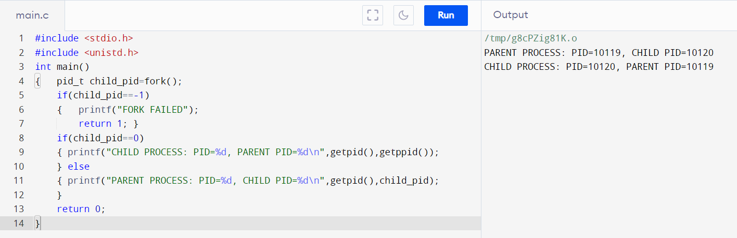

**2.To identify the system calls to copy the content of one file to another and illustrate the same using a C program.**

Program:

#include <stdio.h>

#include <stdlib.h>

int main()

{

FILE *fptr1, *fptr2;

char filename[100], c;

printf("Enter the filename to open for reading \n");

scanf("%s", filename);

fptr1 = fopen(filename, "r");

if (fptr1 == NULL)

{

printf("Cannot open file %s \n", filename);

exit(0);

}

printf("Enter the filename to open for writing \n");

scanf("%s", filename);

fptr2 = fopen(filename, "w");

if (fptr2 == NULL)

{

printf("Cannot open file %s \n", filename);

exit(0);

}

c = fgetc(fptr1);

while (c != EOF)

{

fputc(c, fptr2);

c = fgetc(fptr1);

}

printf("\nContents copied to %s", filename);

fclose(fptr1);

fclose(fptr2);

return 0;

}

INPUT AND OUTPUT:

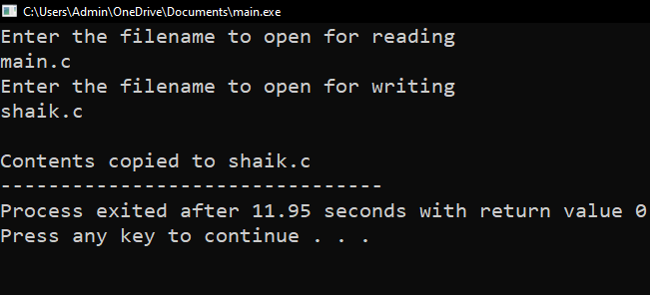

**3.ToDesign a CPU scheduling program with C using First Come First Served technique with the following considerations. a. All processes are activated at time 0. b. Assume that no process waits on I/O devices.**

PROGRAM:

#include<stdio.h>

void main()

{

int n,bt[20],wt[20],tat[20],i,j; float avwt=0,avtat=0;printf("Enter total number of processes(maximum 20):");scanf("%d",&n);

printf("\nEnter Process Burst Time\n");for(i=0;i<n;i++)

{

printf("P[%d]:",i+1);

scanf("%d",&bt[i]);

} wt[0]=0;

for(i=1;i<n;i++)

{ wt[i]=0;for(j=0;j<i;j++)

wt[i]+=bt[j];

}

printf("\nProcess\t\tBurst Time\tWaiting Time\tTurnaround Time"); for(i=0;i<n;i++)

{

tat[i]=bt[i]+wt[i]; avwt+=wt[i]; avtat+=tat[i];printf("\nP[%d]\t\t%d\t\t%d\t\t%d",i+1,bt[i],wt[i],tat[i]);

} avwt/=i; avtat/=i;printf("\n\nAverage Waiting Time:%.2f",avwt);

printf("\nAverage Turnaround Time:%.2f",avtat);

}

INPUT AND OUTPUT:

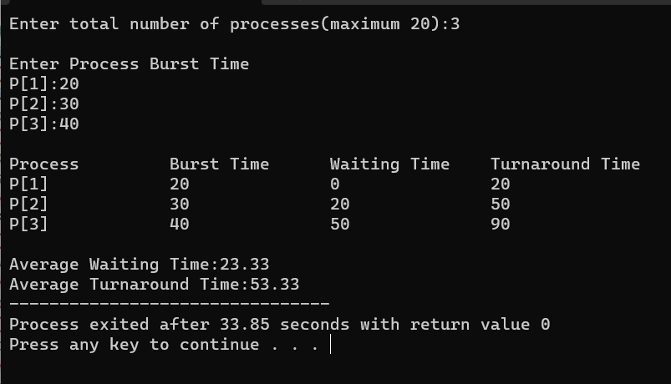

**4.Construct a scheduling program with C that selects the waiting process with the smallest execution time to execute next.**

PROGRAM:

#include <stdio.h>

struct Process {

int id;

int burst_time;

};

int main() {

int n;

printf("Enter the number of processes: ");

scanf("%d", &n);

struct Process processes[n];

int remaining_time[n];

for (int i = 0; i < n; i++) {

processes[i].id = i + 1;

printf("Enter burst time for Process %d: ", i + 1);

scanf("%d", &processes[i].burst_time);

remaining_time[i] = processes[i].burst_time;

}

int current_time = 0;

printf("\nProcess execution order:\n");

while (1) {

int smallest = -1;

for (int i = 0; i < n; i++) {

if (remaining_time[i] > 0) {

if (smallest == -1 || remaining_time[i] < remaining_time[smallest]) {

smallest = i;

}

}

}

if (smallest == -1) {

break;

}

printf("Process %d (Burst Time: %d) is executing from time %d to ", processes[smallest].id, processes[smallest].burst_time, current_time);

current_time += 1;

remaining_time[smallest] -= 1;

printf("time %d\n", current_time);

}

return 0;

}

OUTPUT:

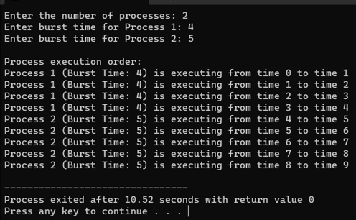

**5. Construct a scheduling program with C that selects the waiting process with the highest priority to execute next.**

PROGRAM:

#include <stdio.h>

struct Process {

int id;

int priority;

int burst_time;

};

int main() {

int n;

printf("Enter the number of processes: ");

scanf("%d", &n);

struct Process processes[n];

for (int i = 0; i < n; i++) {

processes[i].id = i + 1;

printf("Enter priority and burst time for Process %d: ", i + 1);

scanf("%d %d", &processes[i].priority, &processes[i].burst_time);

}

printf("Process Execution Order:\n");

for (int i = 0; i < n; i++) {

int highest_priority_idx = 0;

for (int j = 1; j < n; j++) {

if (processes[j].priority < processes[highest_priority_idx].priority) {

highest_priority_idx = j;

}

}

printf("Executing Process %d (Priority: %d, Burst Time: %d)\n",

processes[highest_priority_idx].id, processes[highest_priority_idx].priority, processes[highest_priority_idx].burst_time);

for (int j = highest_priority_idx; j < n - 1; j++) {

processes[j] = processes[j + 1];

}

n--;

}

return 0;

**}OUTPUT:**

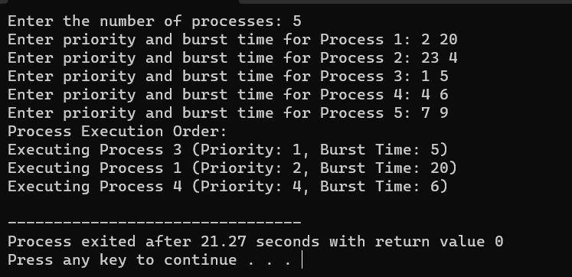

**6.** **Construct a C program to implement pre-emptive priority scheduling algorithm**.

PROGRAM:

#include <stdio.h>

struct Process {

int id, arrival_time, burst_time, priority;

};

int main() {

int n;

printf("Enter the number of processes: ");

scanf("%d", &n);

struct Process processes[n];

for (int i = 0; i < n; i++) {

processes[i].id = i + 1;

printf("Enter arrival time, burst time, and priority for process %d: ", processes[i].id);

scanf("%d %d %d", &processes[i].arrival_time, &processes[i].burst_time, &processes[i].priority);

}

int current_time = 0;

int total_time = 0;

for (int i = 0; i < n; i++) {

total_time += processes[i].burst_time;

}

printf("Gantt Chart: ");

while (current_time < total_time) {

int highest_priority = 9999; // A high value to represent the lowest priority

int selected_process = -1;

for (int i = 0; i < n; i++) {

if (processes[i].arrival_time <= current_time && processes[i].burst_time > 0 && processes[i].priority < highest_priority) {

highest_priority = processes[i].priority;

selected_process = i;

}

}

if (selected_process == -1) {

printf("Idle ");

current_time++;

} else {

printf("P%d ", processes[selected_process].id);

processes[selected_process].burst_time--;

current_time++;

}

}

printf("\n\nProcess\tArrival Time\tBurst Time\tPriority\n");

for (int i = 0; i < n; i++) {

printf("%d\t%d\t\t%d\t\t%d\n", processes[i].id, processes[i].arrival_time, processes[i].burst_time, processes[i].priority);

}

return 0;

}

**OUTPUT:**

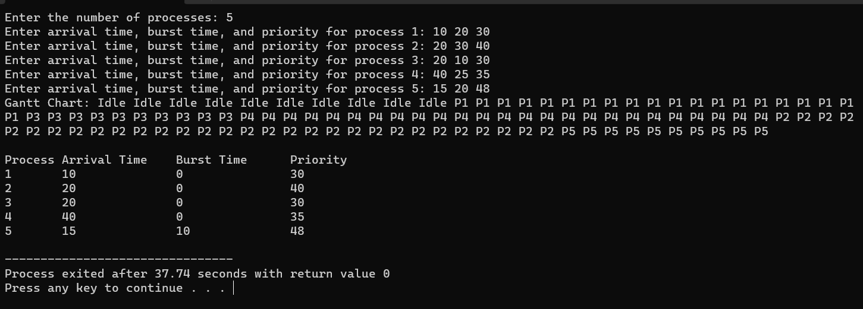

**7.** **Construct a C program to implement non-preemptive SJF algorithm**

PROGRAM:

#include <stdio.h>

struct Process {

int id, arrival_time, burst_time;

};

int main() {

int n;

printf("Enter the number of processes: ");

scanf("%d", &n);

struct Process processes[n];

for (int i = 0; i < n; i++) {

processes[i].id = i + 1;

printf("Enter arrival time and burst time for process %d: ", processes[i].id);

scanf("%d %d", &processes[i].arrival_time, &processes[i].burst_time);

}

for (int i = 0; i < n - 1; i++) {

for (int j = i + 1; j < n; j++) {

if (processes[i].burst_time > processes[j].burst_time) {

struct Process temp = processes[i];

processes[i] = processes[j];

processes[j] = temp;

}

}

}

int waiting_time = 0, turnaround_time = 0;

printf("Process\tBurst Time\tWaiting Time\tTurnaround Time\n");

for (int i = 0; i < n; i++) {

turnaround_time += processes[i].burst_time;

printf("%d\t%d\t\t%d\t\t%d\n", processes[i].id, processes[i].burst_time, waiting_time, turnaround_time);

waiting_time += processes[i].burst_time;

}

float avg_waiting_time = (float)waiting_time / n;

float avg_turnaround_time = (float)turnaround_time / n;

printf("Average Waiting Time: %.2f\n", avg_waiting_time);

printf("Average Turnaround Time: %.2f\n");

return 0;

}

OUTPUT:

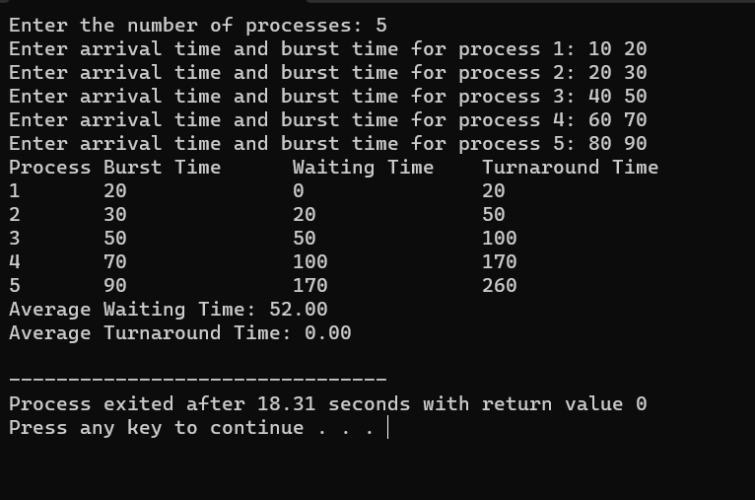

**8. Construct a C program to simulate Round Robin scheduling algorithm with C**

**PROGRAM:**

**#include <stdio.h>**

**struct Process {**

**int id, burstTime, remainingTime;**

**};**

**void roundRobin(struct Process processes[], int n, int quantum) {**

**int time = 0, completed = 0;**

**while (completed < n) {**

**for (int i = 0; i < n; i++) {**

**if (processes[i].remainingTime > 0) {**

**int execTime = (processes[i].remainingTime < quantum) ? processes[i].remainingTime : quantum;**

**processes[i].remainingTime -= execTime;**

**time += execTime;**

**printf("Process %d runs for %d units.\n", processes[i].id, execTime);**

**if (processes[i].remainingTime == 0) {**

**completed++;**

**printf("Process %d has completed.\n", processes[i].id);**

**}**

**}**

**}**

**}**

**}**

**int main() {**

**int n, quantum;**

**printf("Enter the number of processes: ");**

**scanf("%d", &n);**

**struct Process processes[n];**

**for (int i = 0; i < n; i++) {**

**processes[i].id = i + 1;**

**printf("Enter burst time for process %d: ", processes[i].id);**

**scanf("%d", &processes[i].burstTime);**

**processes[i].remainingTime = processes[i].burstTime;**

**}**

**printf("Enter time quantum: ");**

**scanf("%d", &quantum);**

**printf("\nRound Robin Scheduling:\n");**

**roundRobin(processes, n, quantum);**

**return 0;**

**}**

OUTPUT:

